

-----Link of colour code-------

<https://colorhunt.co/palette/05374239a2dba2dbfae8f0f2>

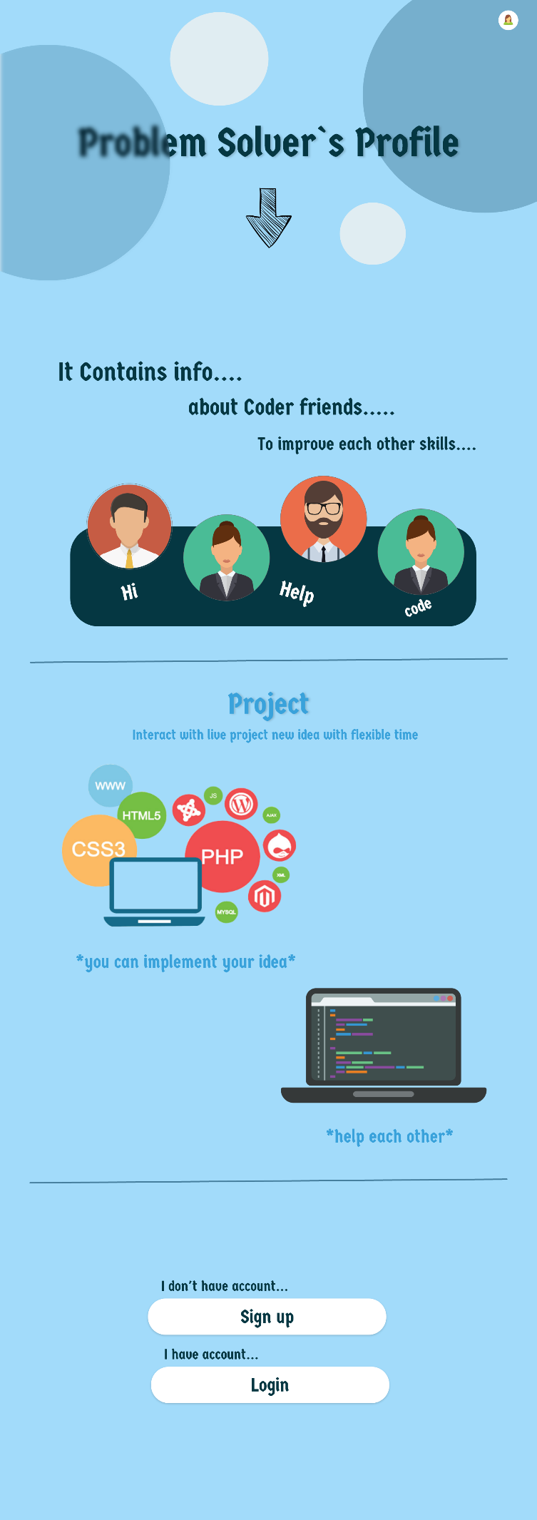  
This is landing page which contain login / sign up

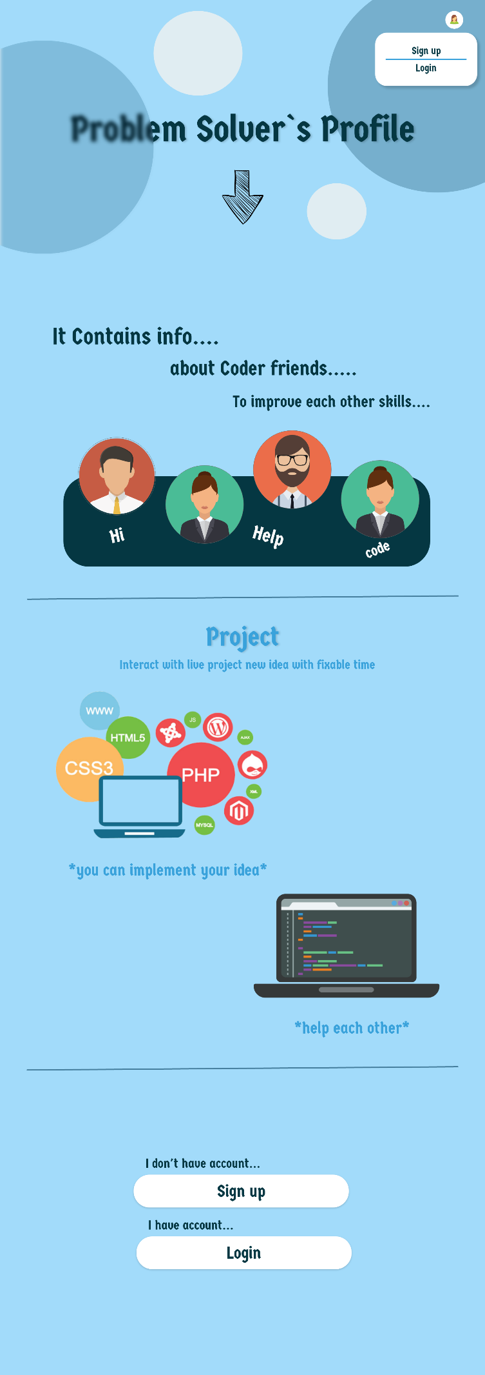

In the top showing menu

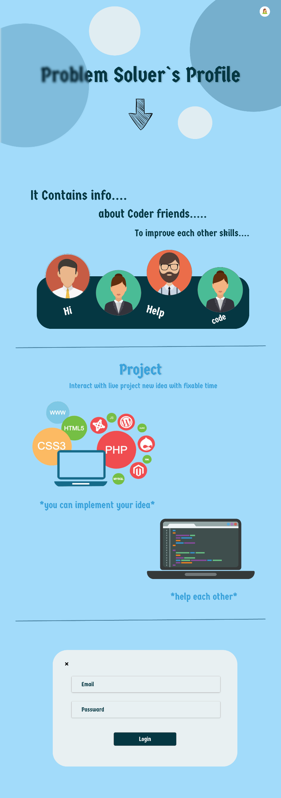 in this page login ui

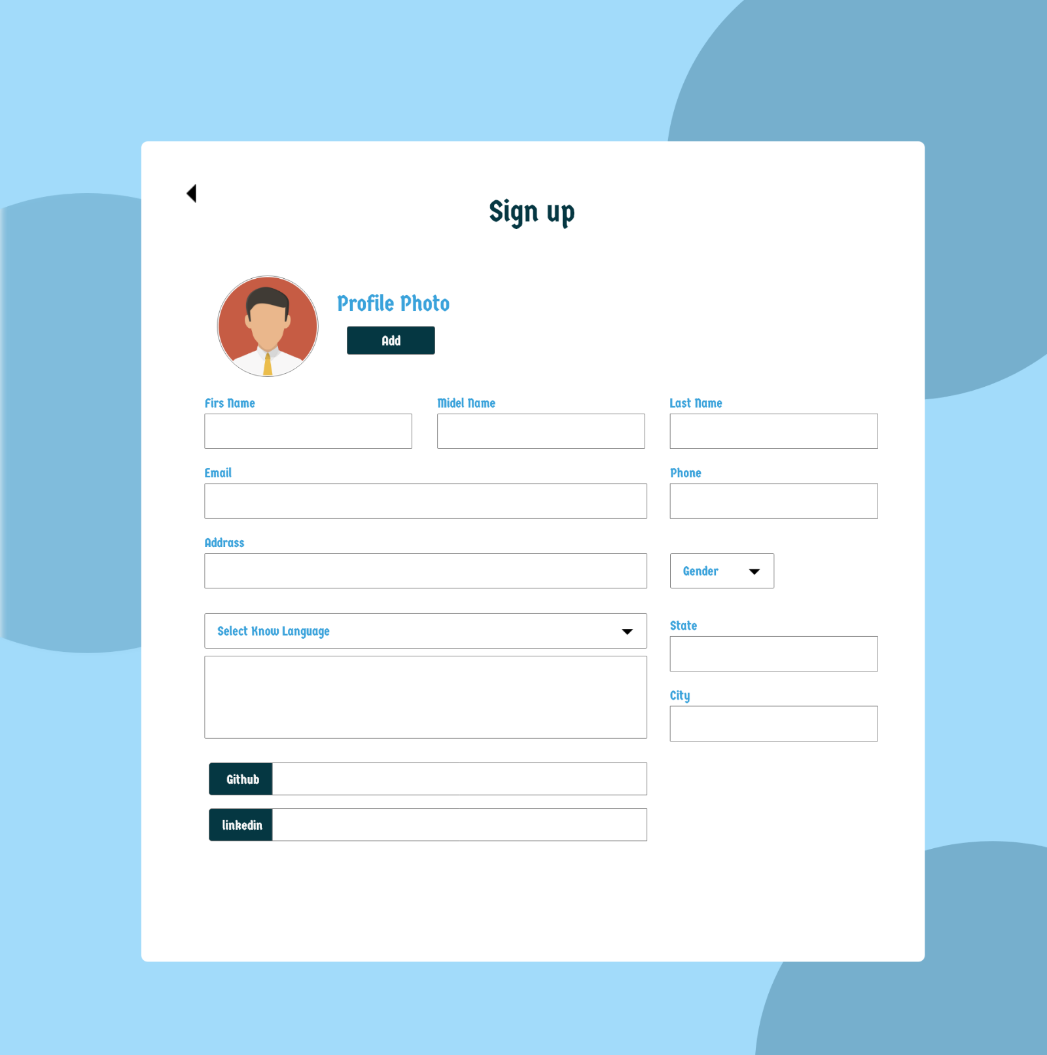

In this page we taking all information of students

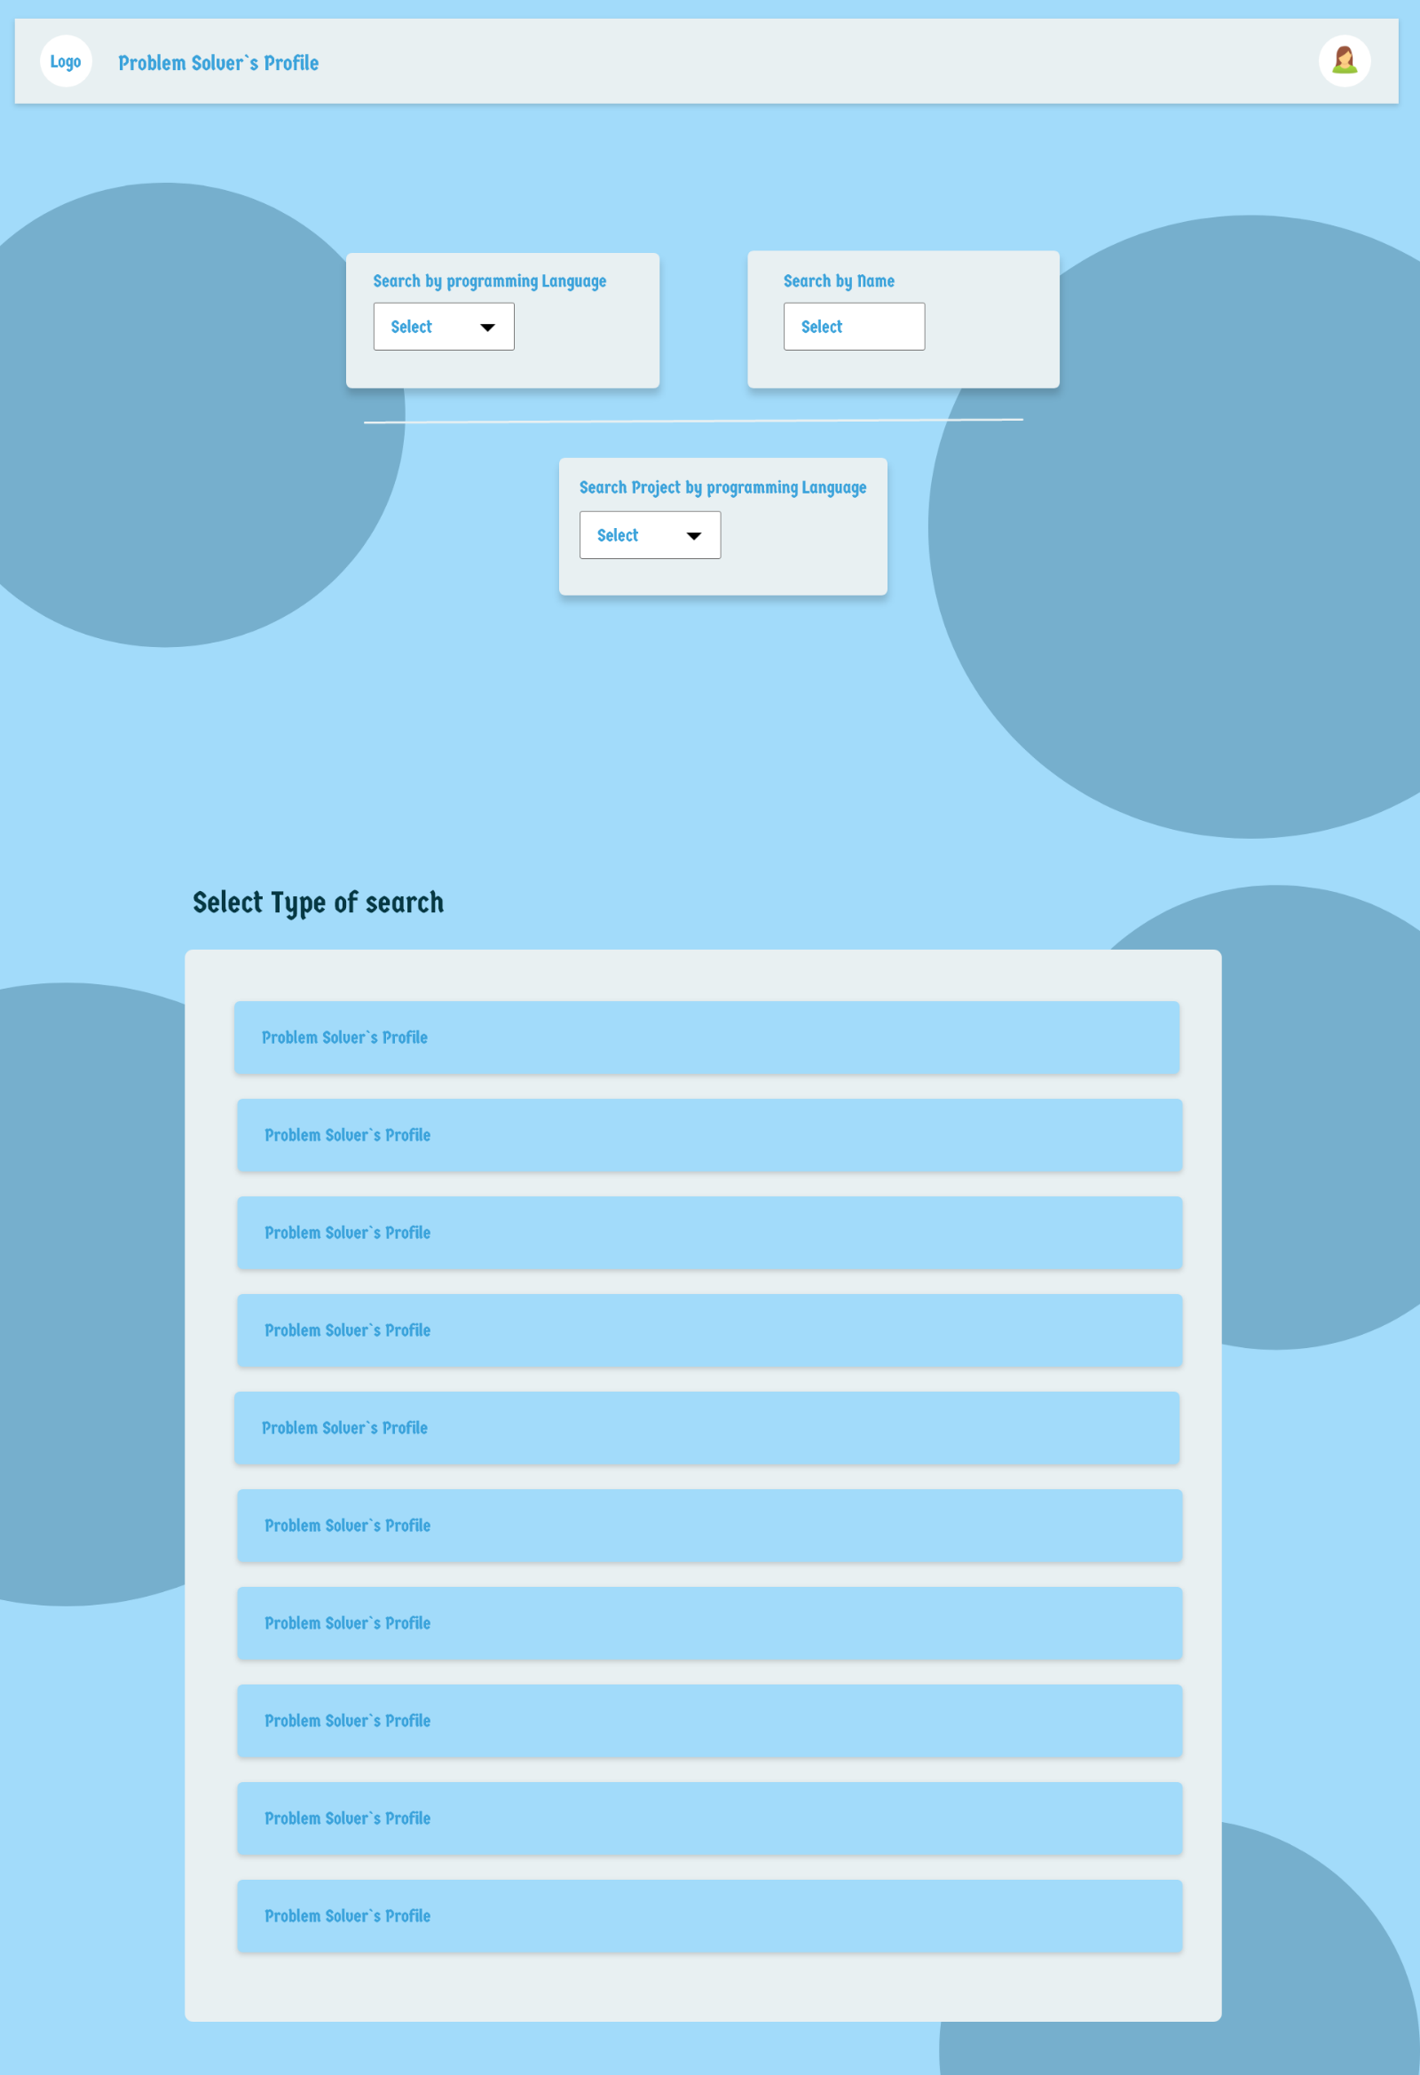

This actual home page

In the top section we give 3 type to search 2 for student search and last for project search

We searched by language , multiple selection is enable

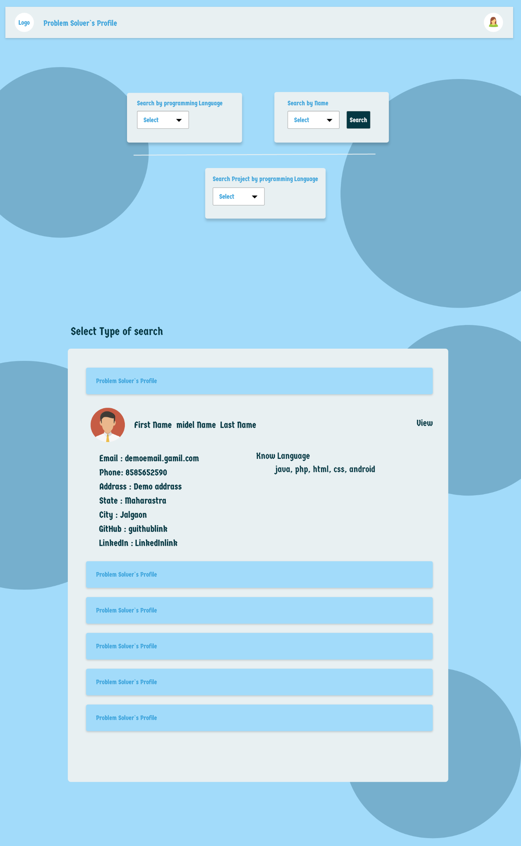

In this section we show brief information about student

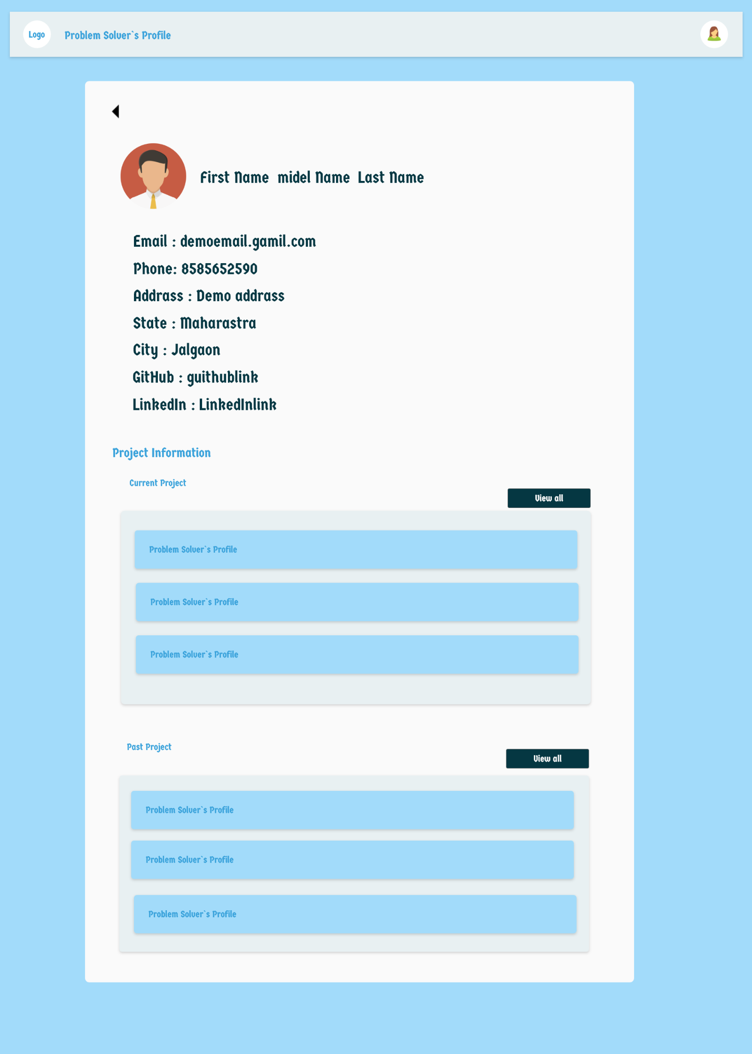

Show student info like this

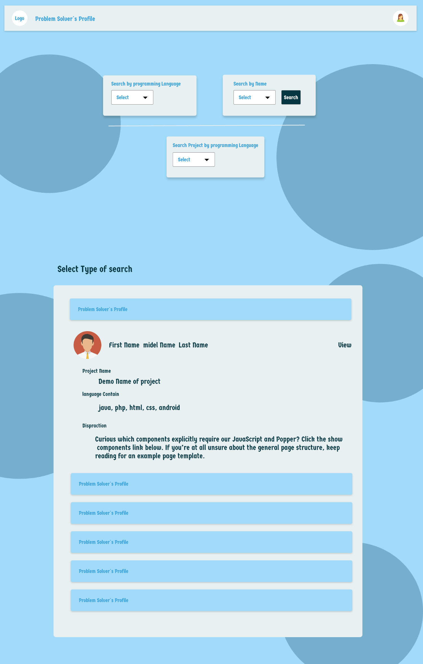

In this section we can show information about project

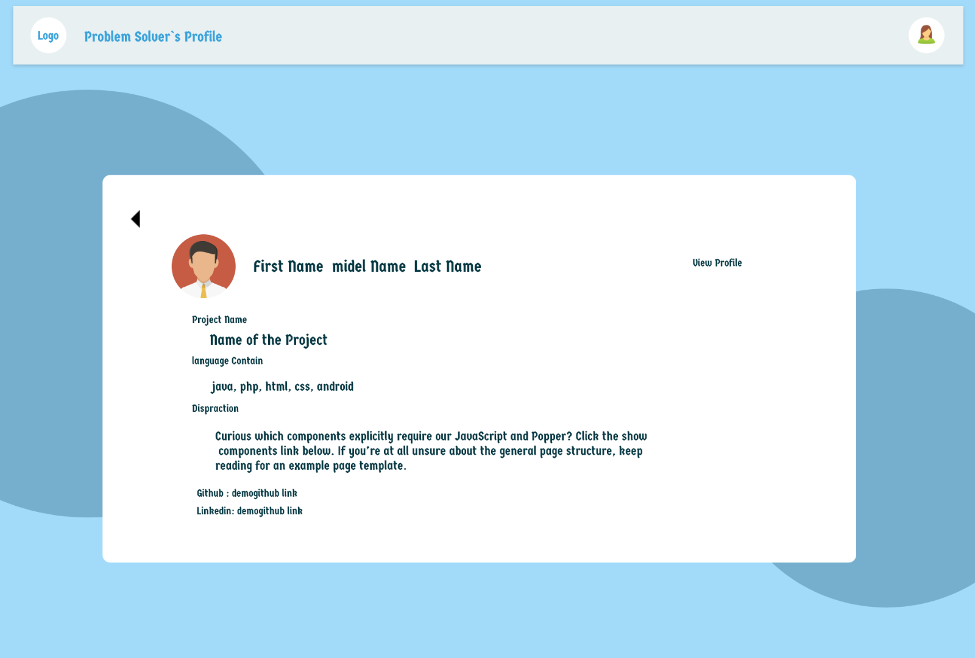

Like this we show informatio about project

--note-

We have to add emdaded vedio player of project

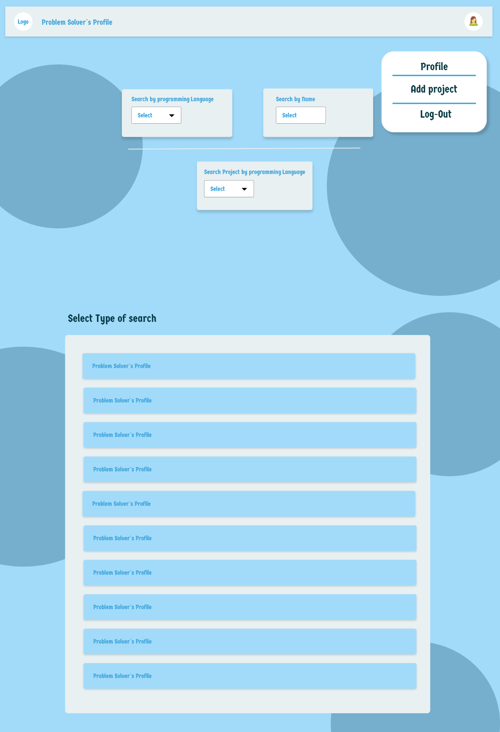

After login we show menu like this

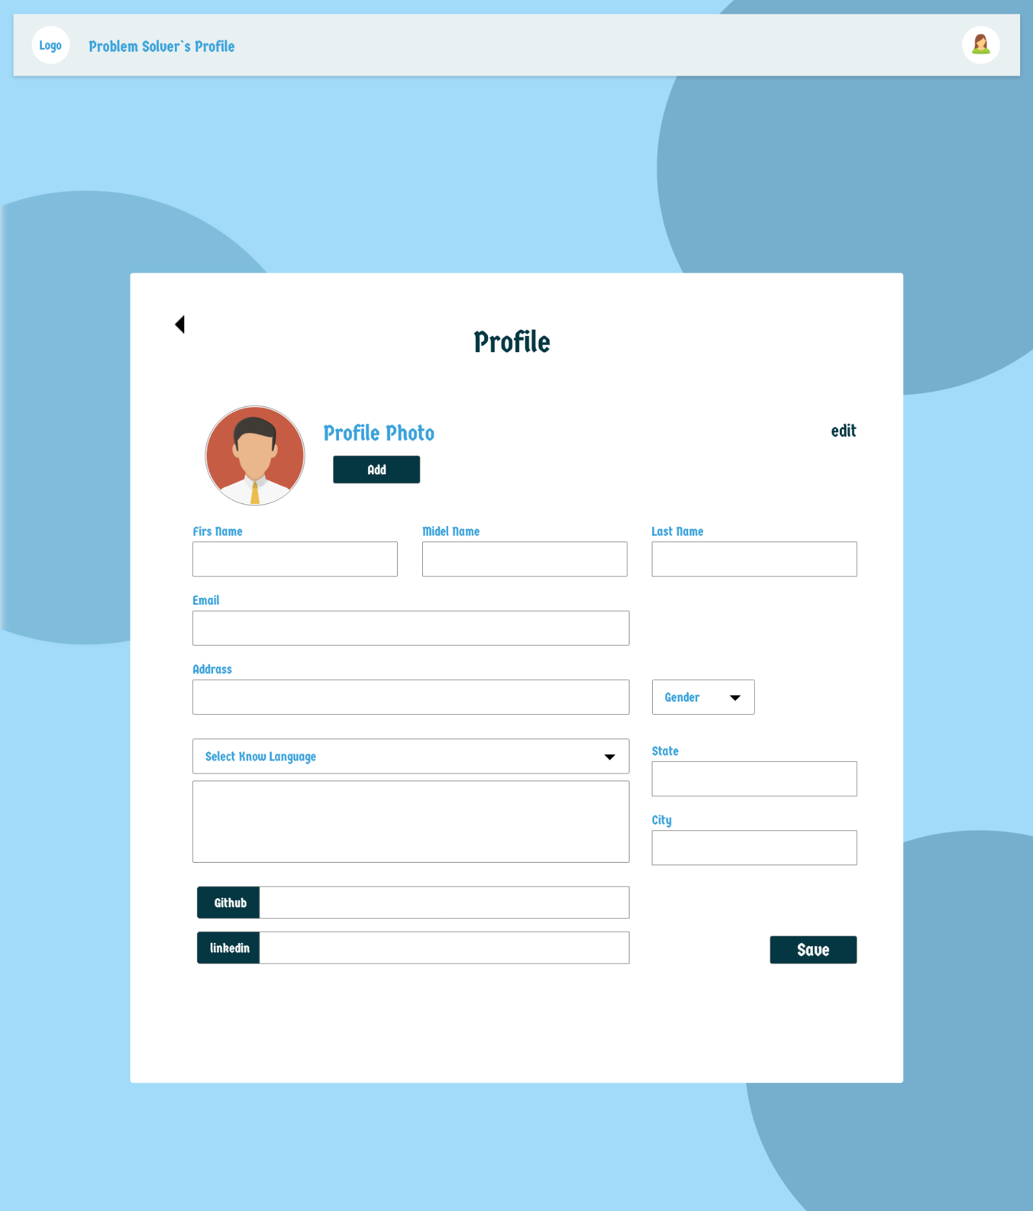

This edit profile ui look

Here student can update his profile

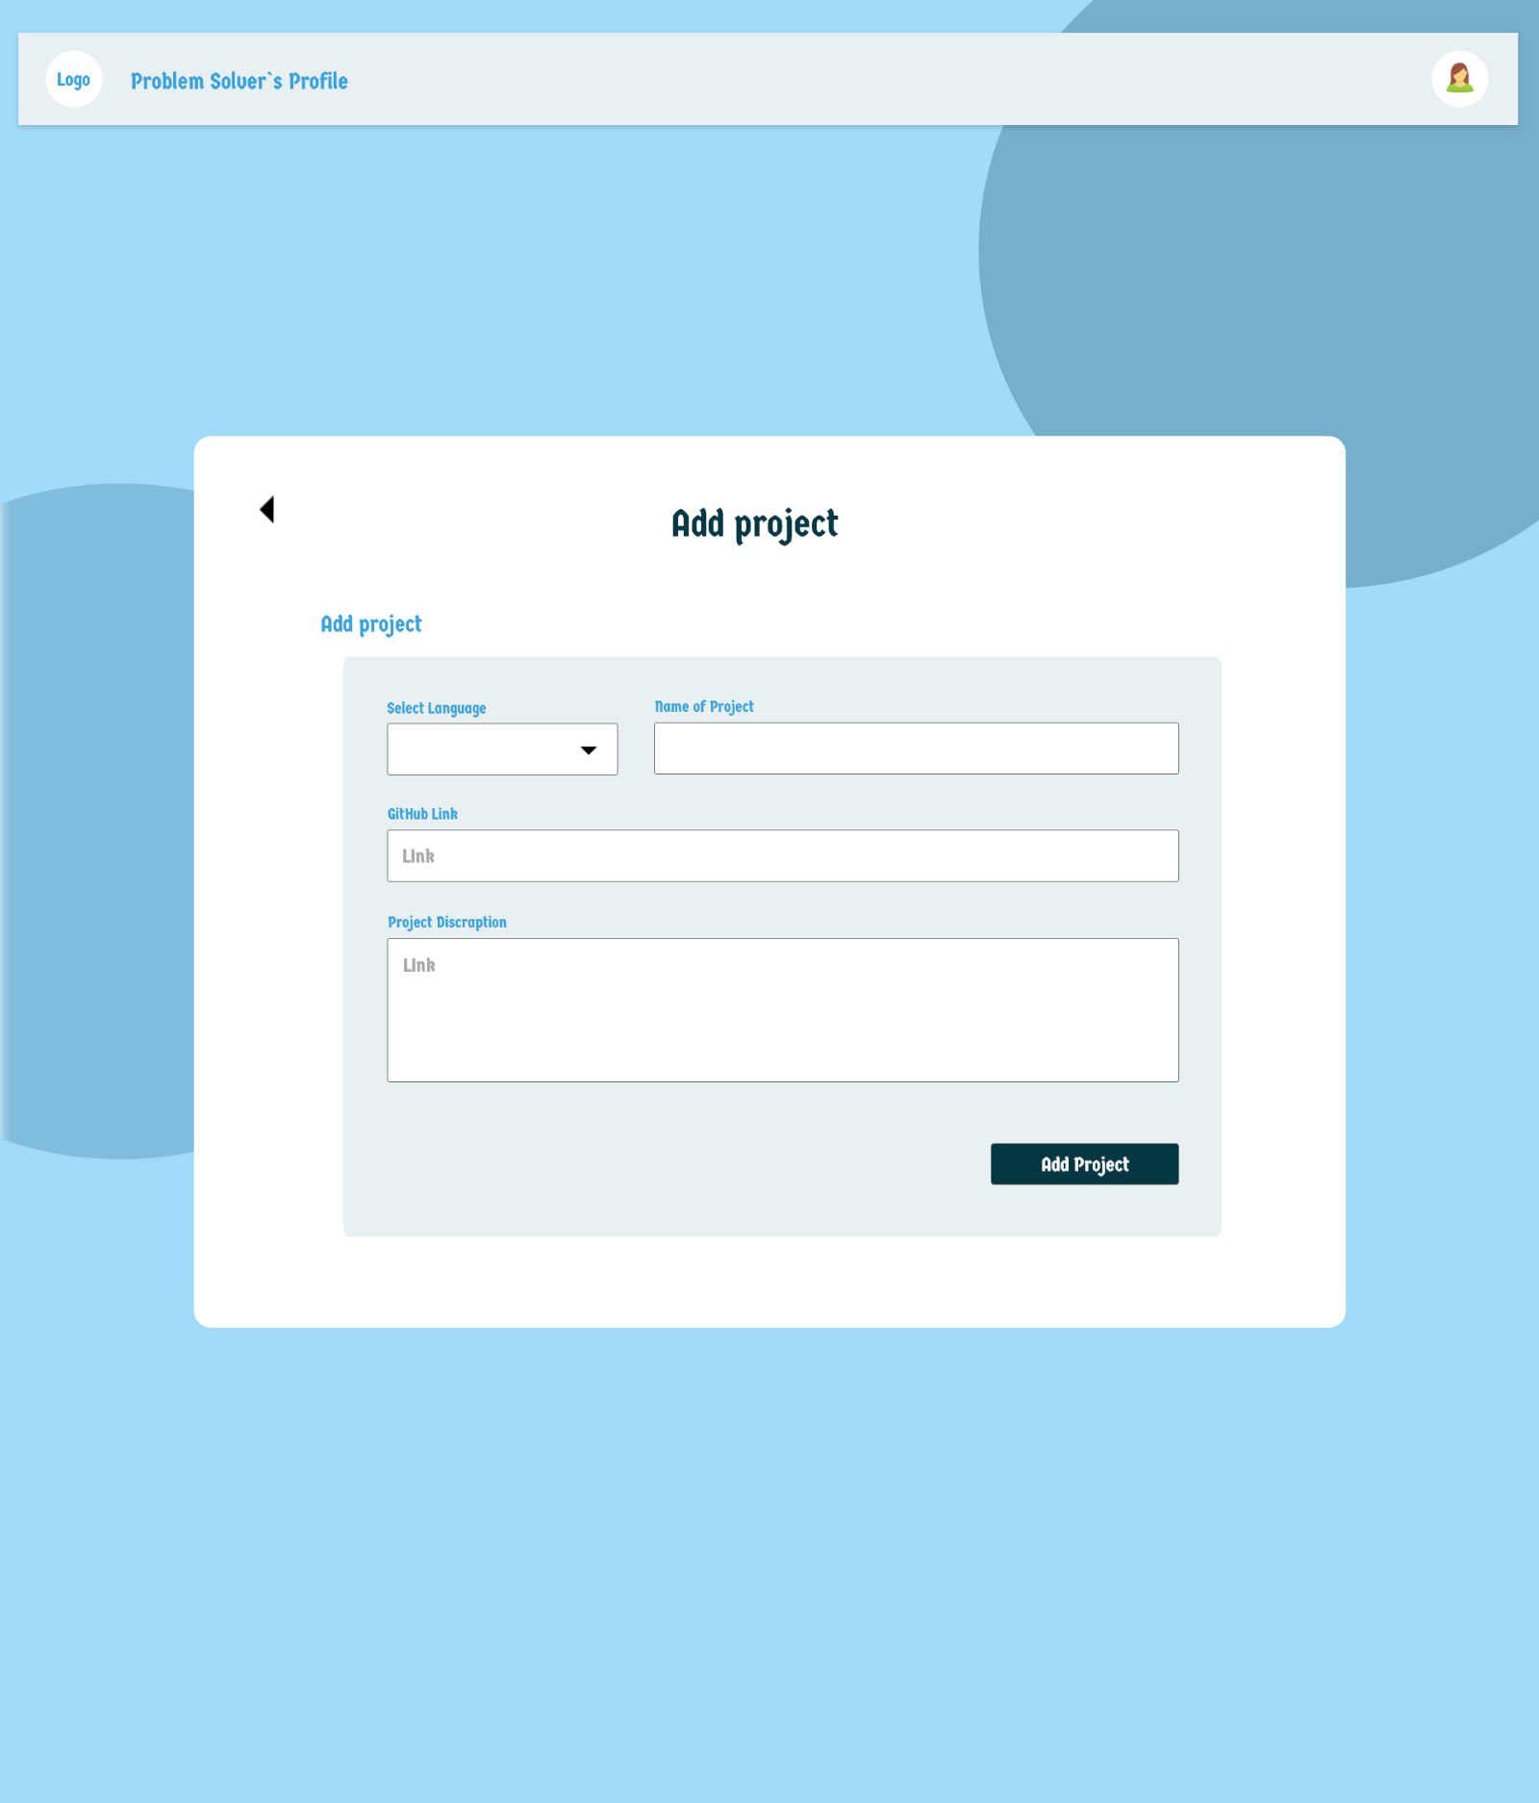

This is ui of adding new project

--note—

Here we have to add input text to add video link